**Docker Compose:**

Installation:

$ sudo curl -L https://github.com/docker/compose/releases/download/1.21.2/docker-compose-`uname -s`-`uname -m` -o /usr/local/bin/docker-compose

Set the permissions:

sudo chmod +x /usr/local/bin/docker-compose

Check docker-compose:

$ docker-compose –version

Running A docker Container With Docker-compose:

$ mkdir hello-world

$ cd hello-world

Create yaml File:

$ vi dockercomposedemo.yml

Press i

my-test:

image: hello-world

Press ESC

:wq

$ docker images

$ docker-compose up

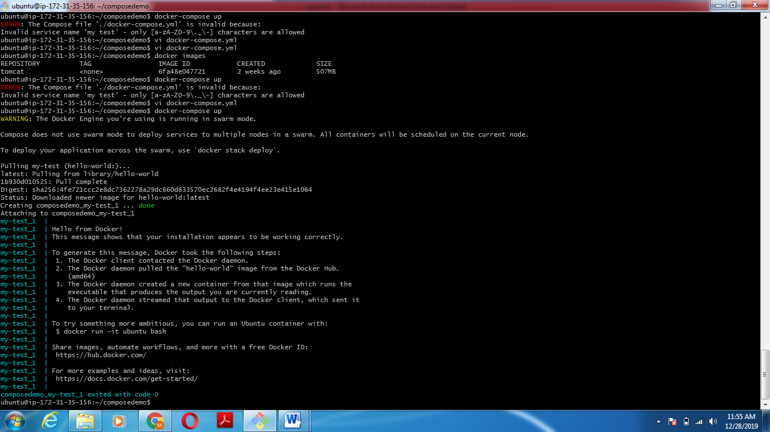

Explanation Of Print After completion Of docker-compose:

Output of docker-compose up

1. The Docker client contacted the Docker daemon.

2. The Docker daemon pulled the "hello-world" image from the Docker Hub.

3. The Docker daemon created a new container from that image which runs the executable that produces the output you are currently reading.

4. The Docker daemon streamed that output to the Docker client, which sent it to your terminal.

<https://www.digitalocean.com/community/tutorials/how-to-install-docker-compose-on-ubuntu-18-04>